# HTML Warm up

1. Find out the new HTML 5 element for specifying an abbreviation or an acronym. Use it in the provided file so when the mouse pointer hovers over the acronym (for instance URL) a tool tip with the definition of the acronym (Uniform Resource Locator) appears. Can you think of ways why this semantic markup is helpful for search engines?
2. Place the proper positioning of the article tags in the provided HTML document
3. Find out how to use the audio element (with displayed controls) to include an .mp3 (or .ogg) audio file in the provided HTML file and auto play upon document loading.
   1. you can use the following url (http://www.wzlonghao.cn/99.mp3) or any other URL to test that your solution works
4. Insert a clickable button in the provided HTML template that upon clicking writes a string message to the console (you can open the browser console in chrome with Ctrl+shift+j or F12)
5. Create the following table in HTML

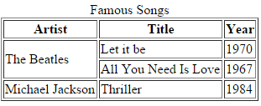

1. Do some research online to find out how the < details> and <summary> elements work, so you can create a line of text that when clicked upon expands to display to the user an in depth definition of a concept

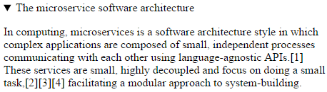

1. Create the following form in HTML. Make sure you use the <datalist> element for Browser input and the date and email input types for inbuilt browser input validation.

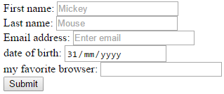

1. Create a minimalistic search form that carries out a Google search for what you enter in the input text field. Hint: name your text input type “q” for it to work with the Google URL (<https://google.com/search>). Make sure you use the placeholder attribute.



1. Use the figure and figure caption elements to generate something similar to the following output:

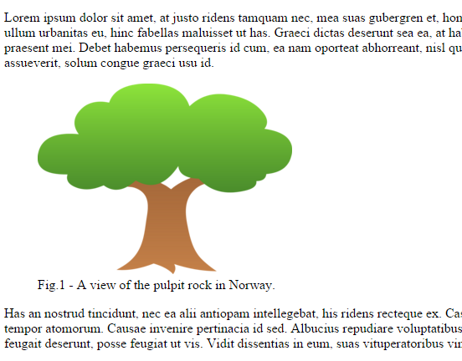

you can use the following URL for the image of the tree: <http://images.clipartpanda.com/tree-clipart-tree_tiny_green_shaded.png>

1. What’s wrong with the provided HTML file? Improve the file to make it semantically more meaningful.